BIOTECH, DEVELOPING AND DEVELOPED COUNTRIES VACCINE MANUFACTURERS
COVID-19 PRESS BRIEFING
Social media pack
This pack contains messages and visuals for leveraging the virtual press briefing on challenges and solutions to scaling up COVID-19 vaccine manufacturing capacity organized by IFPMA, BIO and DCVM on 23 April 2021.
Please feel free to reuse, share and like the messages below, which will be leveraged from @IFPMA on Twitter.

Main resources to leverage:
- Virtual press briefing: https://www.youtube.com/watch?v=B-P8BqHtHj0
- Press release: https://www.ifpma.org/resource-centre/covid-19-vaccine-industry-cautions-immediate-action-needed-to-remove-manufacturing-supply-barriers-to-meet-production-targets-and-keep-on-course-to-equitable-and-fair-access-to-covid-19-vaccines/
- Press briefing event webpage: https://www.ifpma.org/events-2/biotech-developing-and-developed-countries-vaccine-manufacturers-covid-19-press-briefing23april2021/
- IFPMA COVID-19 hub: www.ifpma.org/covid19
Quote cards with key highlights and messages from the speakers will be created and shared after the media briefing.

Join the conversation - popular hashtags
- #COVID19
- #coronavirus
- #SARSCov2

Tweets for DCVMN
Our President Sai D Prasad and CEO Rajinder Suri joined industry colleagues in a virtual press briefing organized by @IFPMA, @IAmBiotech & DCVMN to discuss the contribution & difficulties of scaling up #COVID19 vaccines production and longer-term challenges.  🎙️ https://www.youtube.com/watch?v=B-P8BqHtHj0 | 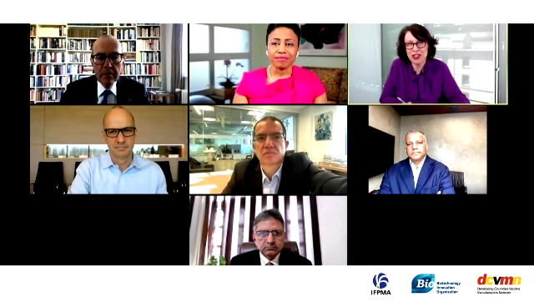
The global biopharmaceutical industry is actively contributing and working together to scale up #COVID19 vaccine production. Find out more about our collective efforts in this @IFPMA, @IAmBiotech & DCVMN:  🎙️ https://www.youtube.com/watch?v=B-P8BqHtHj0 | 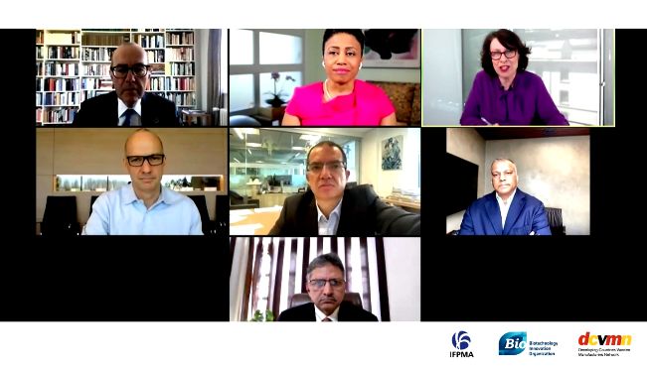
The global biopharmaceutical industry is united in the fight against #COVID19. DCVMN President Sai D Prasad and CEO Rajinder Suri joined a @IFPMA, @IAmBiotech & DCVMN briefing to discuss challenges and solutions to scaling up vaccines manufacturing capacity.  🎙️ https://www.youtube.com/watch?v=B-P8BqHtHj0 | 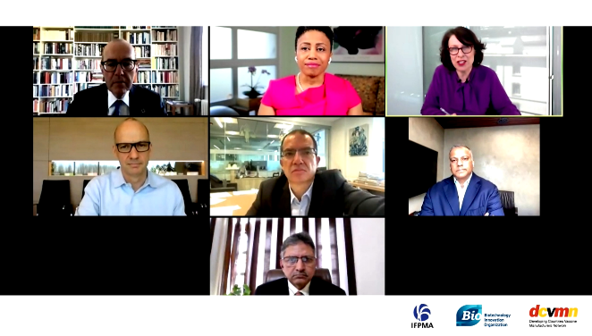
Tweet from IFPMA – please feel free to retweet
.@IFPMA media briefing 23 April, with:

◽️Roger Connor, @GSK & #COVAX representative
◽️Stéphane Bancel, @moderna_tx
◽️Sai Prasad, @BharatBiotech & DCVMN
◽️Rajinder Suri, DCVMN
◽️Dr. Michelle McMurry-Heath, @IAmBiotech

🎙️ https://www.youtube.com/watch?v=B-P8BqHtHj0

